**Empowering 10,000 Tier-3 College Students:**

**Skilling Initiative through Online Learning and Trainers Support**

**Concept Note by**

**WinVinaya Foundation**

Date of Proposal: 18 April 2024

Version 1.0

Project Contact: Sivasankar Jayagopal,

Founder Chairman

WinVinaya Foundation

25/3, Brindavan 3rd Cross,

Saraswathipuram IIM Post

Bengaluru 560076

Ph.: +91-96764-33359

Email: [info@winvinayafoundation.org](mailto:info@winvinayafoundation.org)

**Project Title:** Empowering 10,000 Tier-3 College Students: Skilling Initiative through Online Learning

**Duration:**  June 2024 – May 2025

**Project Location:** Karnataka and Tamil Nadu

1. **Introduction**

In the 21st century, the digital revolution has become the cornerstone of global economic growth, reshaping industries and creating a surge in demand for skilled professionals, particularly in the technology sector. However, amidst this rapid transformation, many educational institutions, particularly colleges in Tier 3 cities/towns, continue to grapple with the challenge of providing comprehensive digital courses and English communication skills to their students. This disparity in access to digital education and English communication skills has widened the skills gap, posing a significant hurdle for students to become job ready.

Recognizing the specific need to address this disparity and bridge the digital divide, WinVinaya Foundation proposes a transformative skilling initiative by harnessing the full potential of technology aimed at empowering 10,000 College students from Tier 3 cities/towns with essential digital and communication skills. Through targeted interventions and inclusive strategies, this initiative seeks to equip marginalized groups with the tools and knowledge needed to thrive in the digital age, fostering greater inclusion and opportunities for all.

WinVinaya Foundation, is a Charitable Trust whose primary aim is to empower Persons with Disabilities, economically disadvantaged and women to lead a life with dignity by providing life skills and resources. We cater to 18 disabilities and have **trained** **1200+ candidates** (Persons with Disabilities, Women) hailing from **24 states of India** – across various IT and digital skills that include Full Stack Software Development, Software Testing, Microsoft Power BI, Financial Accounting, Basic Computer skills and Accessibility Testing skills which help them to get into high-end job roles. To date, we have **placed 425+ candidates** in various MNCs and MSMEs. For a detailed breakdown of the job roles our candidates have secured, including those from diverse backgrounds, you can explore our interactive Power BI dashboard here: <https://winvinayafoundation.org/performance-reports/>. For more information about the WinVinaya Foundation: <https://winvinayafoundation.org/>.

1. **Background / Problem Statement**

The digital revolution has emerged as a fundamental driver of global economic expansion, fundamentally altering industries, and sparking an increased demand for proficient professionals, notably within the technology sector. However, many Tier 3 colleges in villages lack the resources to properly train students in digital skills, with some even lacking basic computer facilities. This lack of access to digital education has widened the digital skills gap, especially for economically disadvantaged students, women, and individuals with disabilities (PWD), hindering their ability to fully leverage the benefits of technology. Consequently, these students often face challenges such as job interview rejections, limited job opportunities, and other setbacks, compounded by difficulties in English communication even after completing their graduation.

In response to these challenges, WinVinaya has developed a customized curriculum tailored to students from Tier 3 colleges. This curriculum places a strong emphasis on improving both communication skills and digital proficiency.

1. **Objectives**

The project aims to directly benefit **10,000 college students**, whether they are in their **first, second, or final year, studying in Tier 3 cities or towns**. These students may come from economically disadvantaged backgrounds, **be female, or have disabilities** they attend Tier 3 colleges located in economically weaker sections.

* Equip the students with English communication skills and in-demand digital skills relevant to the current job market.
* Promote greater access to digital education for students in Tier-3 colleges.
* This project is aligned to UN SDG’S goals of Quality Education (SDG:4) Gender Quality (SDG:5)
* Reduced Inequalities (SDG:10)

Refer to Appendix 1 for more information on how the objectives of the project aligned with UN SDG’s Goals.

1. **Activities and Methodology**

4.1 Curriculum

WinVinaya Academy is an online learning platform for students that offers a range of courses including English, Core Banking, MS Excel, MS Power BI, MS Teams, Full Stack Java Development, SQL, HR processes, and more. These courses cater to both STEM and non-STEM candidates, equipping them with essential skills needed to thrive in today's globalized era. The aim is to foster a passion for continuous learning among all students.

The training curriculum comprises theoretical sessions, assignments, case studies, and practical exercises. Utilizing presentations, videos, and the WinVinaya Academy platform, students will have access to comprehensive training materials. They have the flexibility to select courses based on their individual interests and preferences.

4.2 Assessment and Certification

Our trainers will monitor students' progress, ensuring course completion, and providing assistance through WhatsApp groups to address any queries. Continuous assessment of students' performance will be conducted, with progress reports shared with college authorities. Upon successful completion of the course, students will receive certificates from WinVinaya Academy.  
  
The beneficiaries will receive **one-year** access to the **WinVinaya Academy** platform. WinVinaya Academy is **India's First Online Digital Learning platform** for a range of beneficiaries – including Persons with Disabilities, Women and Underserved communities. It offers courses in Indian Sign Language and Simple English. Providing the candidates access to WinVinaya Academy facilitates them to practice anywhere and anytime what they have learnt during the classroom sessions. Also, they can learn any new courses that they are interested in. Refer to Appendix 2 for more information on WinVinaya Academy.     
  
WinVinaya will offer job assistance to these students upon completion of the course. Additionally, there will be three touch points at that time to monitor progress.

1. **Output & Outcome:**

The success of the project will be measured against the following key performance indicators (KPIs):

* Number of students successfully completing the digital skills training program.
* Improvement in students' digital literacy assessed through pre- and post-training tests.
* Increased placement rates for graduates with demonstrably strong digital skills.
* Enhanced participation of women and PWD students in the program.

1. **Cost Estimates**

We are seeking funding support in the amount of Rs. 6.25 Crores. The budget will cover expenses such as WinVinaya Academy License Cost**,** Trainers Support & Project Management.

|  |  |  |
| --- | --- | --- |
| **Sl.no.** | **Cost Head** | **Total Cost** |
| **1** | WinVinaya Academy License Cost (10,000 Students) | ₹ 4,00,00,000 |
| **2** | Trainers Support (50 Trainers for 1 year) | ₹ 2,00,00,000 |
| **3** | Project Management (5 PMs for 1 year) | ₹ 25,00,000 |
| **Total** | | ₹ 6,25,00,000 |

1. **Sustainability and Monitoring**

* Monthly Status Report (Updated courses, Progress, Issues, Accomplishments) will be shared by WinVinaya Foundation.
* The trainer will monitor progress in the WhatsApp support group, where students can freely ask trainers any course-related doubts.
* Conduct monthly review calls with colleges.
* Analyze placement rates.

1. **Conclusion**

The proposed skilling initiative aims to empower Tier-3 college students, especially PWDs and women, with essential digital skills. By bridging the digital divide, we create a more inclusive and equitable society, where every individual can thrive in the digital age.

Appendix 1: The Objectives of this project aligned to United Nations Sustainable Development Goals (UN SDGs)    
  
SDG 4: Quality Education:

* Providing digital literacy training to Women
* Providing access to WinVinaya Academy to these learners.

SDG 5: Gender Equality:

* The project aims to empower PWD & women by providing them with the necessary skills and knowledge to succeed in the technology industry, which is currently male dominated.

SDG 10: Reduced Inequalities:

* The project addresses inequalities by providing digital education to marginalized groups, including Persons with Disabilities (PWDs) and women.

Appendix 2: WinVinaya Academy  

WinVinaya Academy (WVA) is India’s First Digital Learning Academy designed for Persons with Disabilities where courses are available in **Indian Sign Language** and in **simple English**.

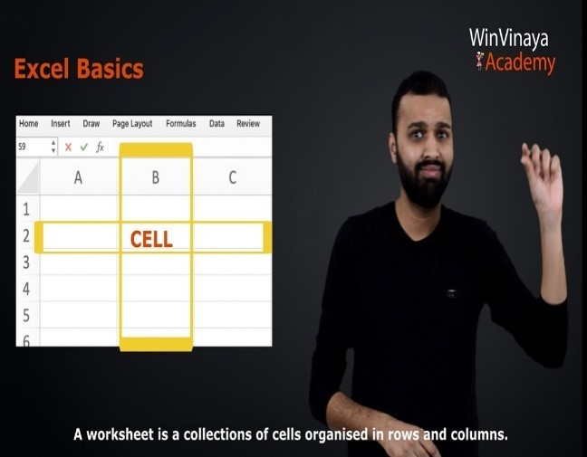

WVA has courses in English, Core Banking, MS Excel, MS Power BI, MS Teams, Full Stack Java Development, SQL, HR process and more to cater to STEM and non-STEM candidates.

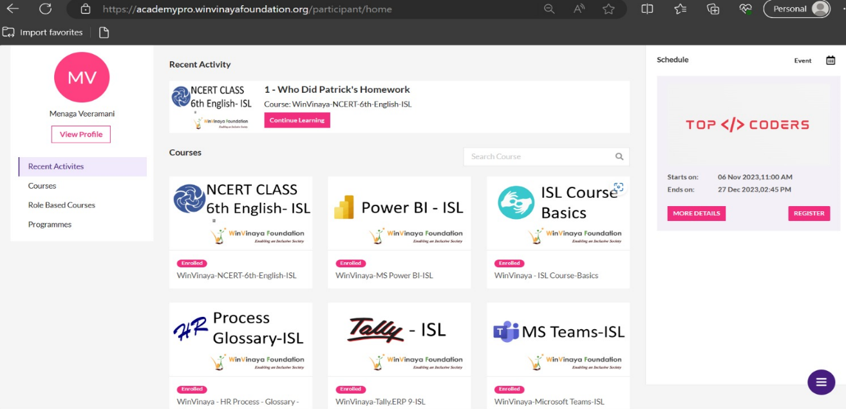

This platform is available on the cloud, so the candidates can learn anytime, anywhere. 90% of the course content is experiential learning with a lot of exercises aligned to industry needs.

**Every course has 3 modules –**

* iLearn (with Micro Learning Videos)
* iPractice (Hundreds of exercises with a combination of auto evaluation and expert evaluation)
* iAssess (Exercises to be solved within a time duration like exams/ interviews)

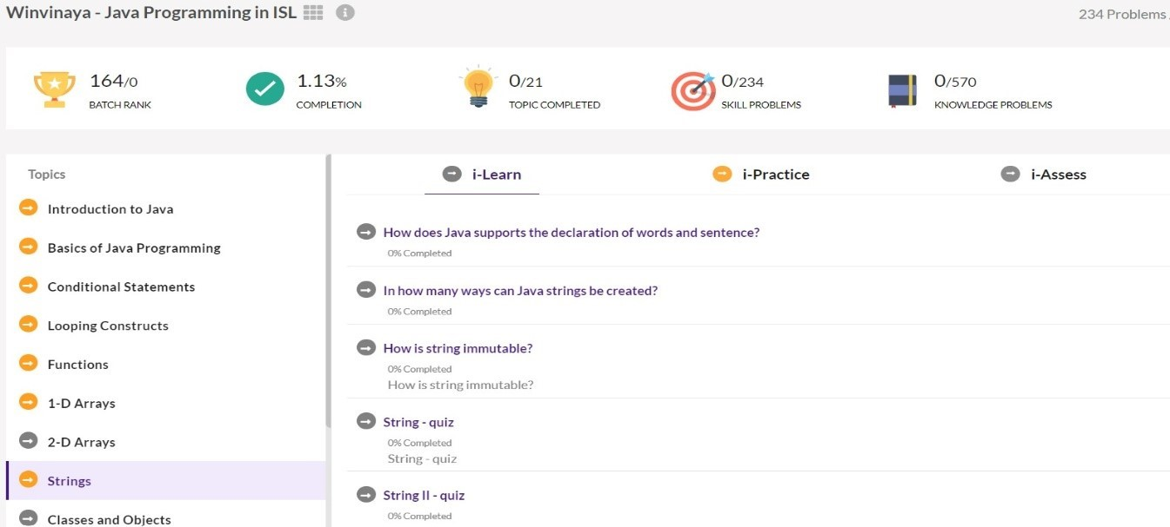

This platform provides a code editor and an in-built compiler which is very useful for the candidates to practice software programs. These programs will be auto evaluated against the preloaded test cases (positive, negative, edge cases). This helps the candidates improve their coding skills and clearing the online programming tests conducted by most of the IT companies as part of their initial technical round. 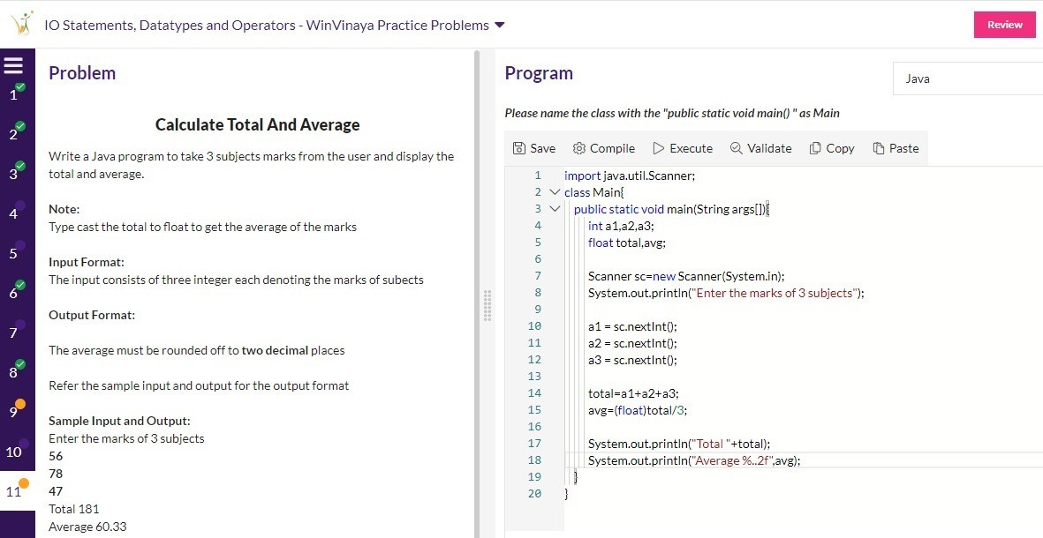

In addition to direct coding practice, the academy provides different self-evaluation techniques like quizzes, code analysis, and such.

